**SQL Queries**

1. Overall attrition

SELECT COUNT(CASE WHEN attrition = 'Yes' THEN 'Yes' END) AS AttritionCount,

COUNT(*) AS Total_Employees

FROM HR;

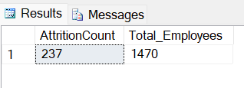

1. Prescence of overtime and correlation with attrition

SELECT Overtime, COUNT(*) AS Total_Employees

FROM HR

WHERE Attrition = 'Yes'

GROUP BY OverTime;

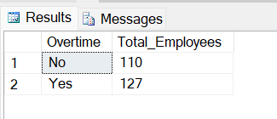

1. Gender distribution in the company

SELECT Gender, COUNT(*) AS Total_employees, COUNT(CASE WHEN Attrition = 'YES' THEN 'YES' END) AS Attrition FROM HR

GROUP BY Gender;

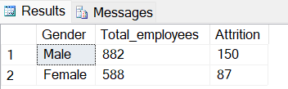

1. Performance rating and attrition

SELECT PerformanceRating, COUNT(CASE WHEN Attrition = 'YES' THEN 'YES' END) AS Attrition

FROM HR

GROUP BY PerformanceRating;

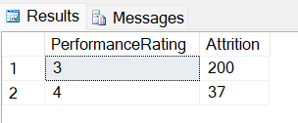

1. Attrition count based on job roles

SELECT Department, JobRole, COUNT(JobRole) as Total_Employees, COUNT(CASE WHEN Attrition = 'YES' THEN 'YES' END) AS Attrition

FROM HR

GROUP BY Department, JobRole

ORDER BY Attrition DESC;

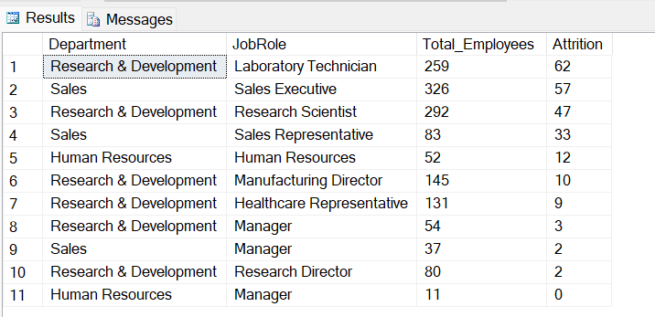

1. Employee attrition based on the age range

SELECT CASE WHEN Age <= 29 THEN '18-29'

WHEN Age >= 30 AND Age <= 39 THEN '30-39'

WHEN Age >= 40 AND Age <= 49 THEN '40-49'

WHEN Age >= 50 AND Age <= 59 THEN '50-59'

ELSE '60 Or Older'

END AS 'Age range', COUNT(*) AS 'Number of attrition based on age range'

FROM HR

WHERE Attrition = 'Yes' AND YearsAtCompany >=1

GROUP BY CASE WHEN Age <= 29 THEN '18-29'

WHEN Age >= 30 AND Age <= 39 THEN '30-39'

WHEN Age >= 40 AND Age <= 49 THEN '40-49'

WHEN Age >= 50 AND Age <= 59 THEN '50-59'

ELSE '60 Or Older'

END;

